Ideation Phase
Brainstorm & Idea Prioritization Template

Date | 20 January 2026
Team ID | LTVIP2026TMIDS90862
Project Name | Prosperity Prognosticator: Machine Learning for Startup Success Prediction
Maximum Marks | 4 Marks

Brainstorm & Idea Prioritization Template:
Brainstorming was conducted within the team to identify possible approaches for solving the problem of startup success prediction. During this session, different technical solutions and implementation strategies were discussed. The objective of this brainstorming activity was to evaluate feasible machine learning models and determine the most suitable approach for developing a predictive system.

Step-1: Team Gathering, Collaboration and Select the Problem Statement
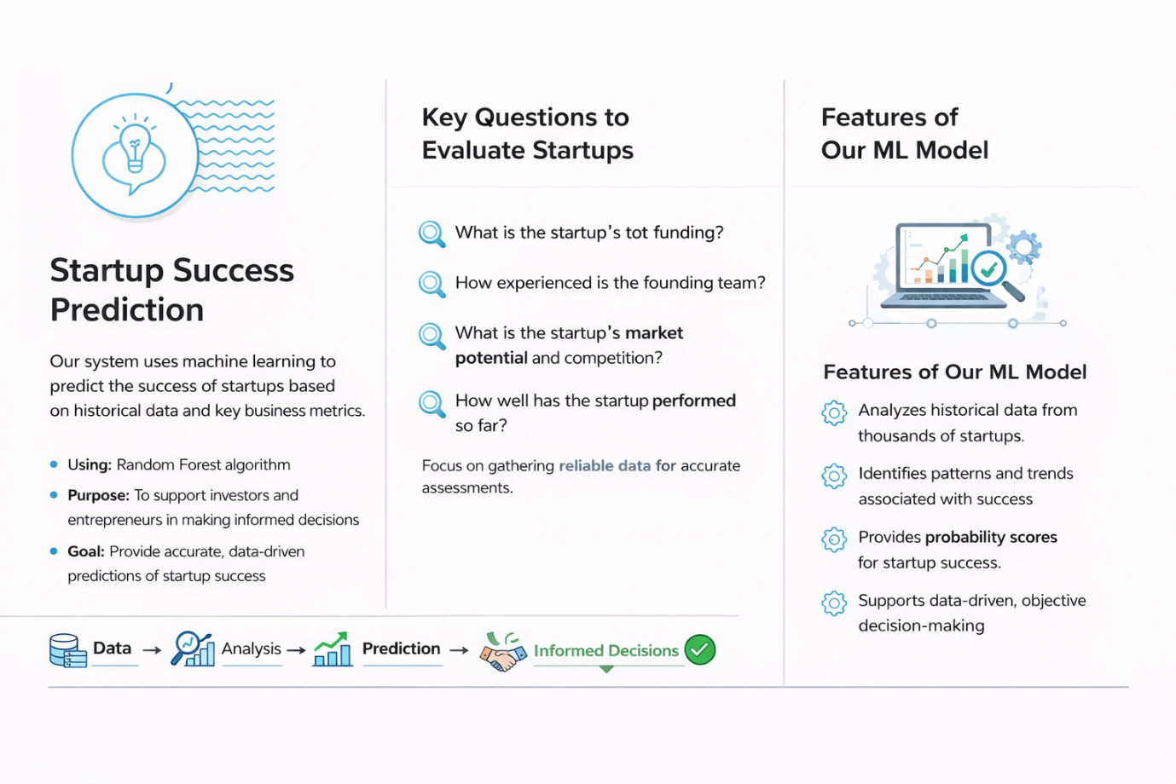

Step-2: Brainstorm, Idea Listing and Grouping


Step-3: Idea Prioritization


